# MySQL Exercise 1

1. Write a program that computes the perimeter and the area of a rectangle. Define your own values for the length and width. (Assuming that *L* and *W* are the length and width of the rectangle, Perimeter = *2*(L+W)* and Area = *L*W*.

**delimiter //**

**create procedure e1(l int ,w int)**

**begin**

**declare perimeter float;**

**declare area float;**

**set perimeter=2*(l+w);**

**set area=l*w;**

**insert into opex1 values('Perimeter',perimeter);**

**insert into opex1 values('Area',area);**

**end;//**

**delimeter ;**

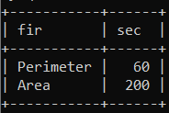

1. Write a program that declares an integer variable called *num*, assigns a value to it, and computes and inserts into the tempp table the value of the variable itself, its square, and its cube.

create procedure e2()

**begin**

**declare num int;**

**declare square float;**

**declare c float;**

**set num=14;**

**if num>0 then**

**set square=num*num;**

**set c=num*num*num;**

**end if;**

**insert into opex1 values('Num',num);**

**insert into opex1 values('Square',square);**

**insert into opex1 values('Cube',c);**

**end;//**

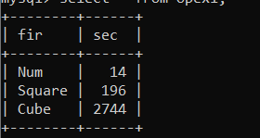

1. Convert a temperature in Fahrenheit (F) to its equivalent in Celsius (C) and vice versa. The required formulae are:- *C*= (*F*-32)*5/9

*F*= 9/5\**C* + 32

**create procedure e3()**

**begin**

**declare t float;**

**declare c float;**

**declare f float;**

**set t=43.2;**

**set c=(t-32)*(5/9);**

**set f=(9/5*t)+32;**

**insert into opex1 values("Celcius",c);**

**insert into opex1 values("Fahrenheit",f);**

**end;//**

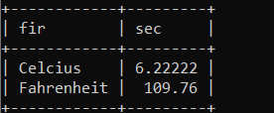

1. Convert a number of inches into yards, feet, and inches. For example, 124 inches equals 3 yards, 1 foot, and 4 inches.

**create procedure e4()**

**begin**

**declare n int;**

**declare yards int ;**

**declare feet int ;**

**declare inches int;**

**set n=124;**

**set yards=floor(n/36);**

**set n=n mod 36;**

**set feet=floor(n/12);**

**set inches=n mod 12;**

**insert into opex1 value("Yards",yards);**

**insert into opex1 value("Feets",feet);**

**insert into opex1 value("Inches",inches);**

**end;//**

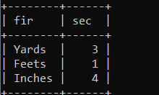

1. Write a program that enables a user to input an integer. The program should then state whether the integer is evenly divisible by 5.

**create procedure e5(n int)**

**begin**

**if n%5=0 then**

**insert into opex1 values("Divisible",n);**

**else**

**insert into opex1 values(" Not Divisible",n);**

**end if;**

**end;//**

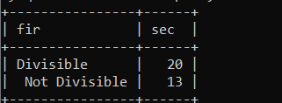

1. Your block should read in two real numbers and tell whether the product of the two numbers is equal to or greater than 100.

**create procedure e6(x int,y int)**

**begin**

**declare res int;**

**set res=x*y;**

**if res>=100 then**

**insert into opex1 values("Greater",res);**

**else**

**insert into opex1 values(" Not Greater ",res);**

**end if;**

**end;//**

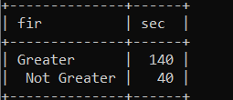

*Sameer Dehadrai*